FreightFlow Control Tower
Shipment Booking, Carrier Coordination, Live Exception Handling & Proof of Delivery Automation
Make.com | Airtable/SmartSuite | Gmail | Slack | Google Maps API | Google Drive | Google Sheets | DocuSign | Twilio/WhatsApp | Webhooks | Carrier APIs | OpenAI/Claude

Project Overview
Built an automated logistics control system for managing shipment booking, carrier selection, pickup coordination, live tracking, delivery exceptions, proof of delivery, and carrier performance.
The workflow takes a new shipment request and turns it into a complete logistics lifecycle, from carrier sourcing and dispatch to delivery confirmation and operational reporting.
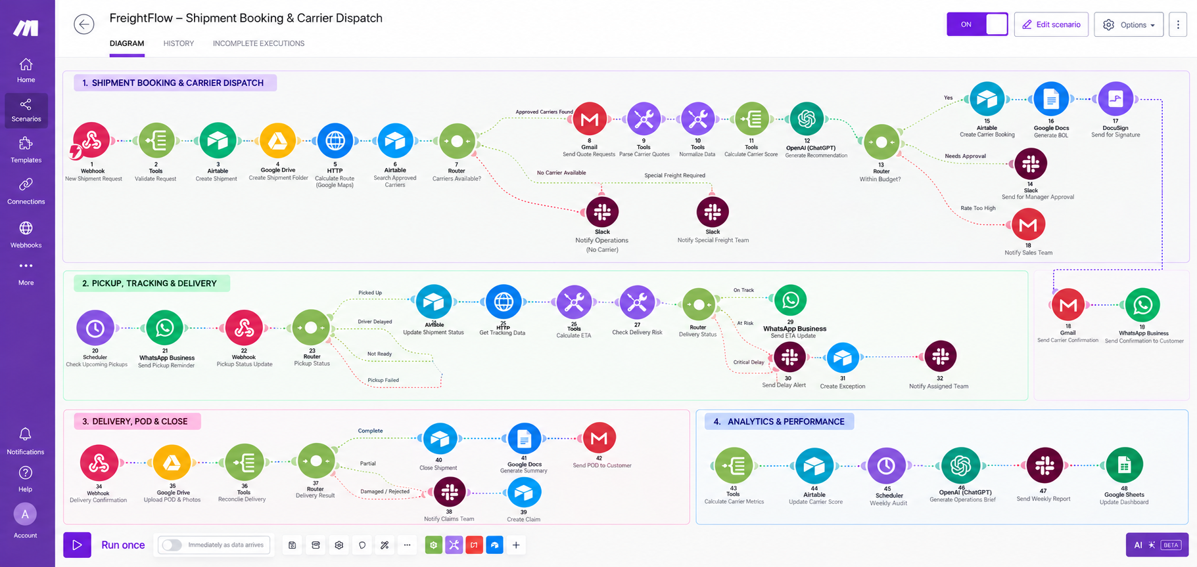
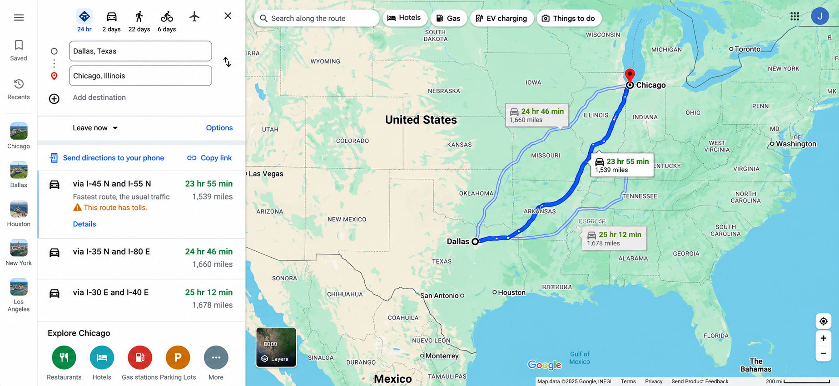
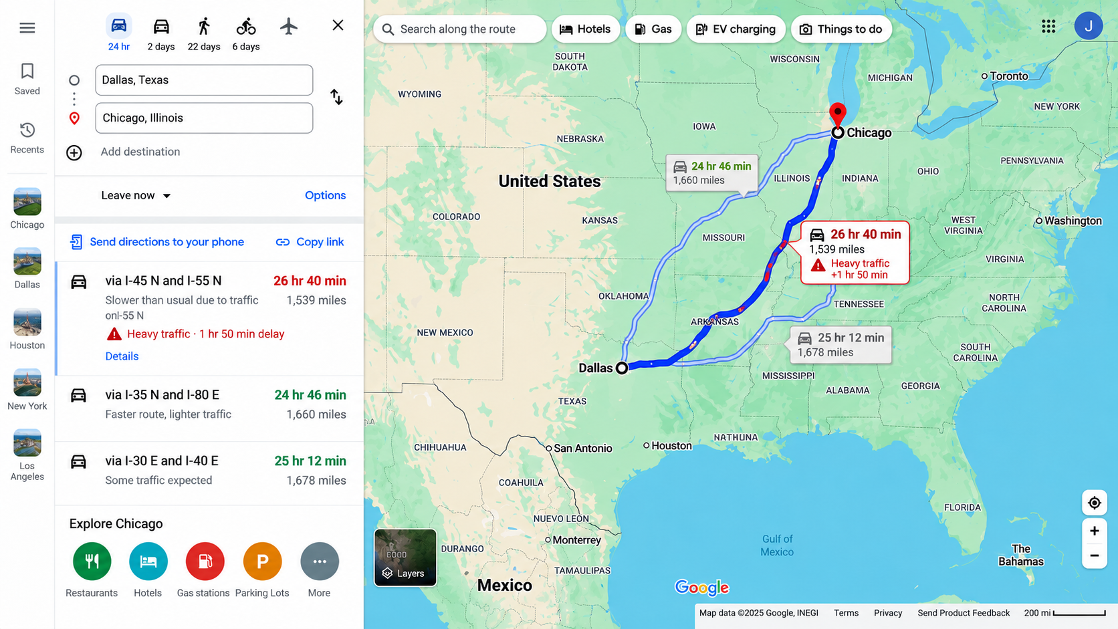
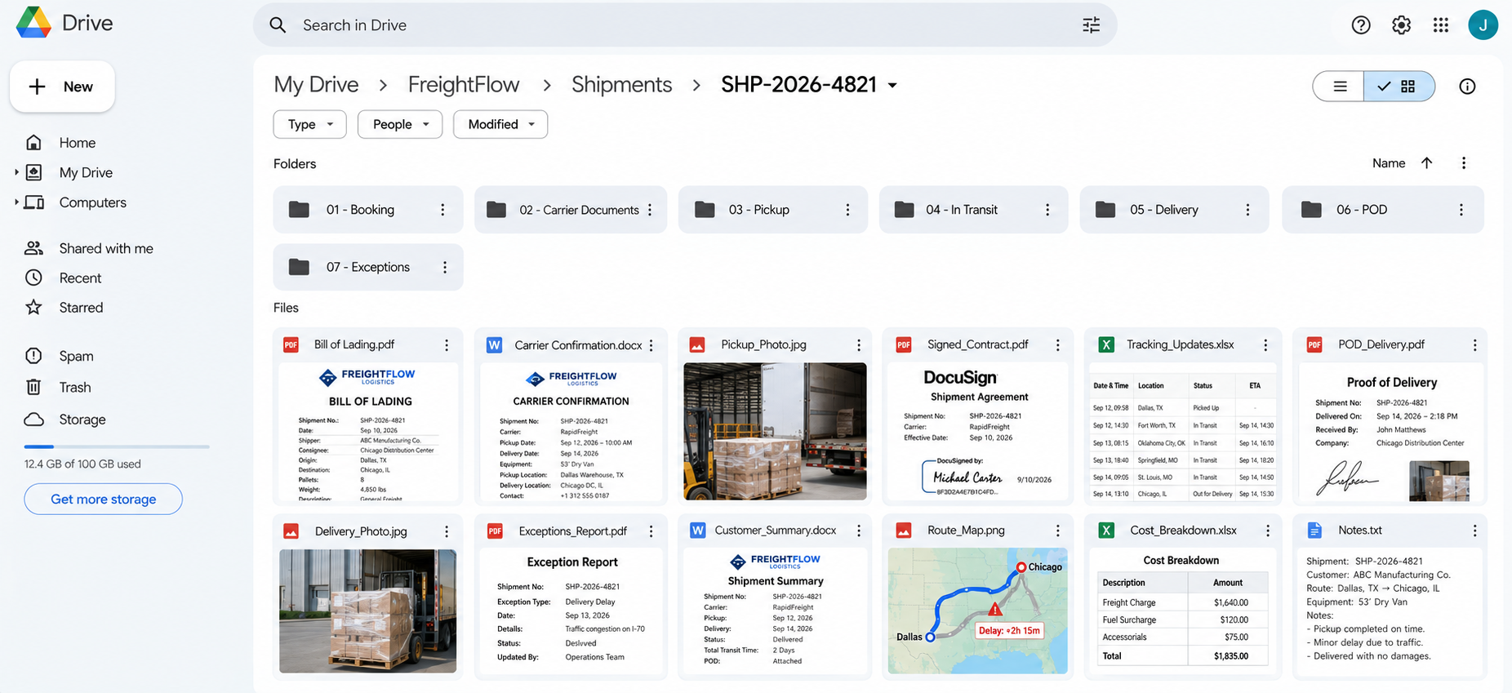
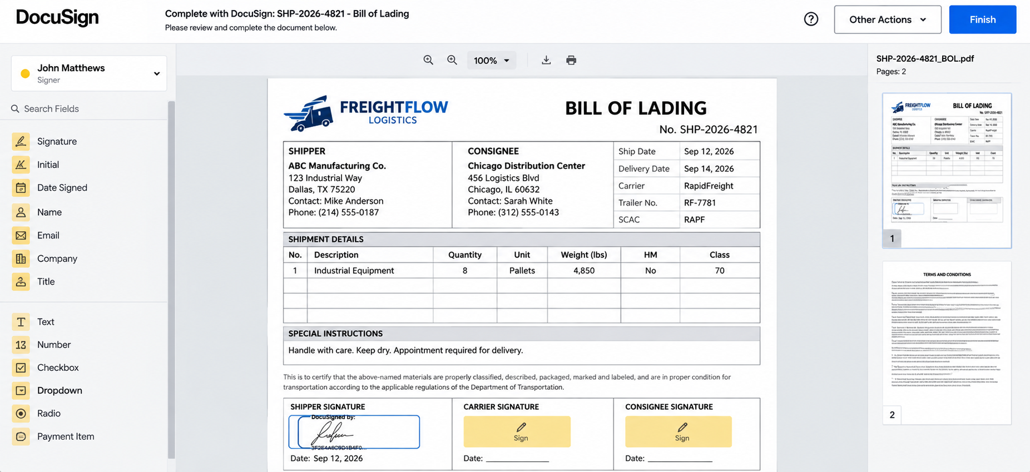
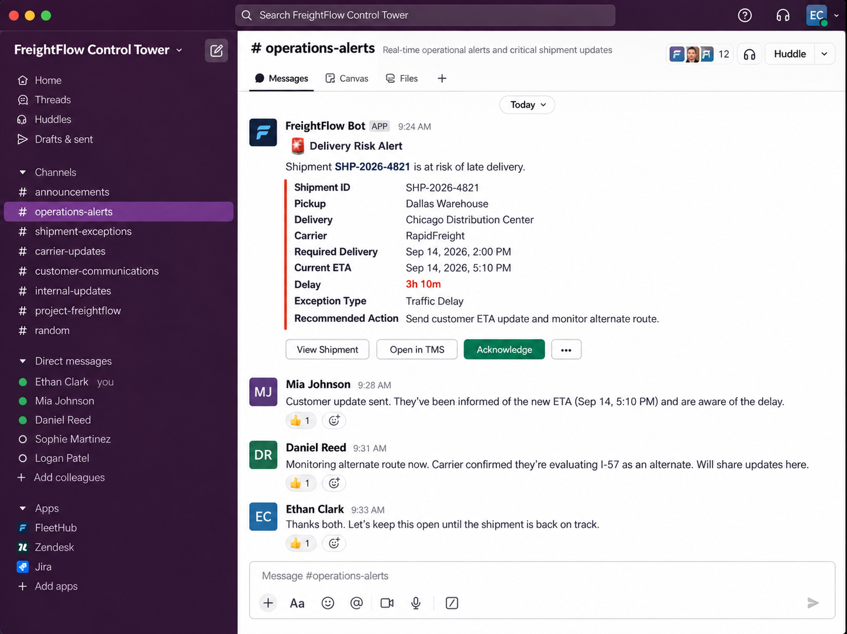

Workflow
The system:
- Receives new shipment requests through webhooks or forms
- Validates shipment, customer, route, cargo, and delivery information
- Creates shipment records and dedicated Google Drive folders
- Calculates routes, travel distance, and estimated transit time
- Searches approved carriers based on service region, capacity, equipment, and compliance
- Sends quotation requests to suitable carriers
- Receives, normalizes, and compares carrier quotations
- Calculates carrier scores using price, availability, reliability, damage rate, and on-time performance
- Generates recommended carrier summaries using AI
- Routes shipments for manager approval when required
- Creates confirmed carrier bookings automatically
- Generates shipping documents and sends required documents through DocuSign
- Sends booking confirmations to carriers and customers
- Monitors upcoming pickups and sends driver reminders
- Processes pickup confirmations, delays, failed pickups, and shipment-not-ready conditions
- Retrieves carrier tracking data and recalculates delivery ETA
- Detects at-risk and critically delayed shipments
- Sends customer ETA updates and operations alerts automatically
- Creates structured exception records for delivery problems
- Receives delivery confirmation, signatures, photos, and proof of delivery
- Reconciles expected and delivered shipment quantities
- Routes partial, damaged, or rejected deliveries to claims handling
- Closes successfully delivered shipments
- Generates final shipment summaries and sends POD documents to customers
- Calculates carrier performance after each completed shipment
- Performs weekly audits for late shipments, missing PODs, open exceptions, and claims
- Updates logistics analytics in Google Sheets

Branding & Templates
The workflow uses predefined shipment, carrier, approval, delivery, and exception templates.
Each template controls:
- Carrier quote requests
- Booking confirmations
- Shipment documents
- Customer status updates
- Delivery exception alerts
This keeps logistics communication consistent across customers, carriers, shipments, and delivery stages.

Content Management
Airtable or SmartSuite acts as the central shipment, carrier, exception, and delivery tracking system.
Each shipment is updated with:
- Shipment status
- Selected carrier
- Carrier score
- Pickup status
- Current ETA
- Delivery risk
- Exception status
- POD status
- Delivery result
- Carrier performance

Technology
- Make.com
- Airtable/SmartSuite
- Gmail
- Slack
- Google Maps API
- Google Drive
- Google Sheets
- DocuSign
- Twilio/WhatsApp
- Webhooks
- Carrier APIs
- OpenAI/Claude

Result
A complete automated logistics pipeline that turns a shipment request into an approved, booked, tracked, delivered, reconciled, and documented shipment without requiring operations teams to manually coordinate every step.
The system also keeps carrier quotations, pickup activity, live ETA, shipment exceptions, proof of delivery, claims, carrier performance, and logistics analytics organized in one workflow.

